Selected Quotes and References on Children’s Mental Health
Compiled by Karen R. Effrem, MD
President – Education Liberty Watch

Subjectivity of Mental Health and Mental Illness Criteria
“There is no scientifically established ideal ‘chemical balance’ of serotonin, let alone an identifiable pathological imbalance.” (Lacasse, J. & Leo, J., PLoS Medicine, 2005)
“Not a single peer-reviewed article ... supports claims of serotonin deficiency in any mental disorder.” (Ibid)

Challenges Involved in Infant and Early Childhood Diagnosis (Zeannah, et al, ADDRESSING SOCIALEMOTIONAL DEVELOPMENT AND INFANT MENTAL HEALTH IN EARLY CHILDHOOD SYSTEMS, National Center for Infant and Early Childhood Health Policy, 2005)
“Diagnostic classifications for infancy are still being developed and validated…”
“Lack of longitudinal outcome studies”
“There is neither a systematic data base, clear criteria for [medication] treatment or dosage recommendations that have been identified or standardized for pediatric use (Greenhill et al. 2003).”
“Broad parameters for determining socioemotional outcomes are not clearly defined”

"Five years ago, pinning down bipolar disorder in children was like nailing Jello to the wall. Today, we've seen significant advances—we are now nailing cheesecake to the wall…so far [genetic] research has not consistently shown increased occurrence of the disorder in children who are supposed to be at high risk.” (Gabrielle Carlson, M.D. Psych News, 12-2-2005)

“It is no secret that our field has published thousands of candidate gene association studies but few replicated findings.” - 2007 article by psychiatric geneticists S.V. Faraone , J.W. Smoller , C.N. Pato, P. Sullivan , and M.T. Tsuang

“Diagnostic categories of mental disorders are social constructions (Bandura, 1969). It is essential, therefore, that the mental health field continually question whether diagnostic categories are defined in ways that serve the best interests of the diagnosed. That is, each of the many aspects of the validity of each diagnosis, including ADHD, must be thoughtfully and persistently questioned.” (Jensen, P. & Cooper, J (2002) Attention Deficit Hyperactivity Disorder: State of the Science - Best Practices Civic Research Institute, Kingston, N.J., p. 1-8, 9)

“Childhood and adolescence being developmental phases, it is difficult to draw clear boundaries between phenomena that are part of normal development and others that are abnormal.” (World Health Organization (2001) World Health Report)

“All of psychiatry¹s diagnoses are merely syndromes [or disorders], clusters of symptoms presumed to be related, not diseases. (Glenmullen, Joseph (2000) Prozac Backlash: Overcoming the Dangers of Prozac, Zoloft, Paxil, and Other Antidepressants with Safe, Effective Alternatives Touchstone/Simon and Schuster, New York, NY p. 195.)

“The diagnosis of mental disorders is often believed to be more difficult than diagnosis of somatic or general medical disorders since there is no definitive lesion, laboratory test or abnormality in brain tissue that can identify the illness.” (US Surgeon General (1999) Report on Mental Health, p. 2-18, http://www.surgeongeneral.gov/library/mentalhealth/pdfs/c2.pdf)

“In other words, what it means to be mentally healthy is subject to many different interpretations that are rooted in value judgments that may vary across cultures.” (US Surgeon General (1999) Report on Mental Health, p. 1-5)

“DSM-IV (Diagnostic and Statistical Manual, 4th Edition) criteria remain a consensus without clear empirical data supporting the number of items required for the diagnosis . . . Furthermore, the behavioral characteristics specified in DSM-IV, despite efforts to standardize them, remain subjective . . . ” (American Psychiatric Association Committee on the Diagnostic and Statistical Manual (DSM IV- 1994), pp.1162-1163)

“‘Fifty percent of Americans mentally impaired - are you kidding me?’ said Dr. Paul McHugh, a professor of psychiatry at Johns Hopkins University…‘While the new survey was carefully done,’ Dr. McHugh said, ‘the problem is that the diagnostic manual we are using in psychiatry is like a field guide and it just keeps expanding and expanding…’ ‘Pretty soon,’ he said, ‘we'll have a syndrome for short, fat Irish guys with a Boston accent, and I'll be mentally ill.’” (Carey, New York Times, 6/7/05)

Influence of the Pharmaceutical Industry on Diagnosis and Medication Prescribing
“All DSM task force members on mood and psychotic disorders tied to drug industry” (Critical Think Rx, Module 8, slide 37, http://criticalthinkrx.org/pdf/m8/Module-8-Complete-Slide-Presentation.pdf)

“From 2000 to 2005, drug maker payments to Minnesota psychiatrists rose more than sixfold, to $1.6 million. During those same years, prescriptions of antipsychotics for children in Minnesota's Medicaid program rose more than ninefold.” (Carey, et al, Psychiatrists, Children and Drug Industry's Role, New York Times, 5/10/07)

“In 2007, a series of investigative reports revealed that an influential advocate for diagnosing bipolar disorder in kids, the Harvard psychiatrist Joseph Biederman, failed to disclose money he’d received from Johnson & Johnson, makers of the bipolar drug Risperdal, or risperidone.” (Greenberg, Inside the Battle to Define Mental Illness, Wired Magazine, 12/27/10)

“As reported to Senator Grassley, pharmaceutical companies contributed an average of 56% of national NAMI's budget annually for the period 2005 to 2009” LETTER FROM NAMI EXECUTIVE DIRECTOR MICHAEL J. FITZPATRICK, April 28, 2009 http://www.mindfreedom.org/kb/psych-drug-corp/nami

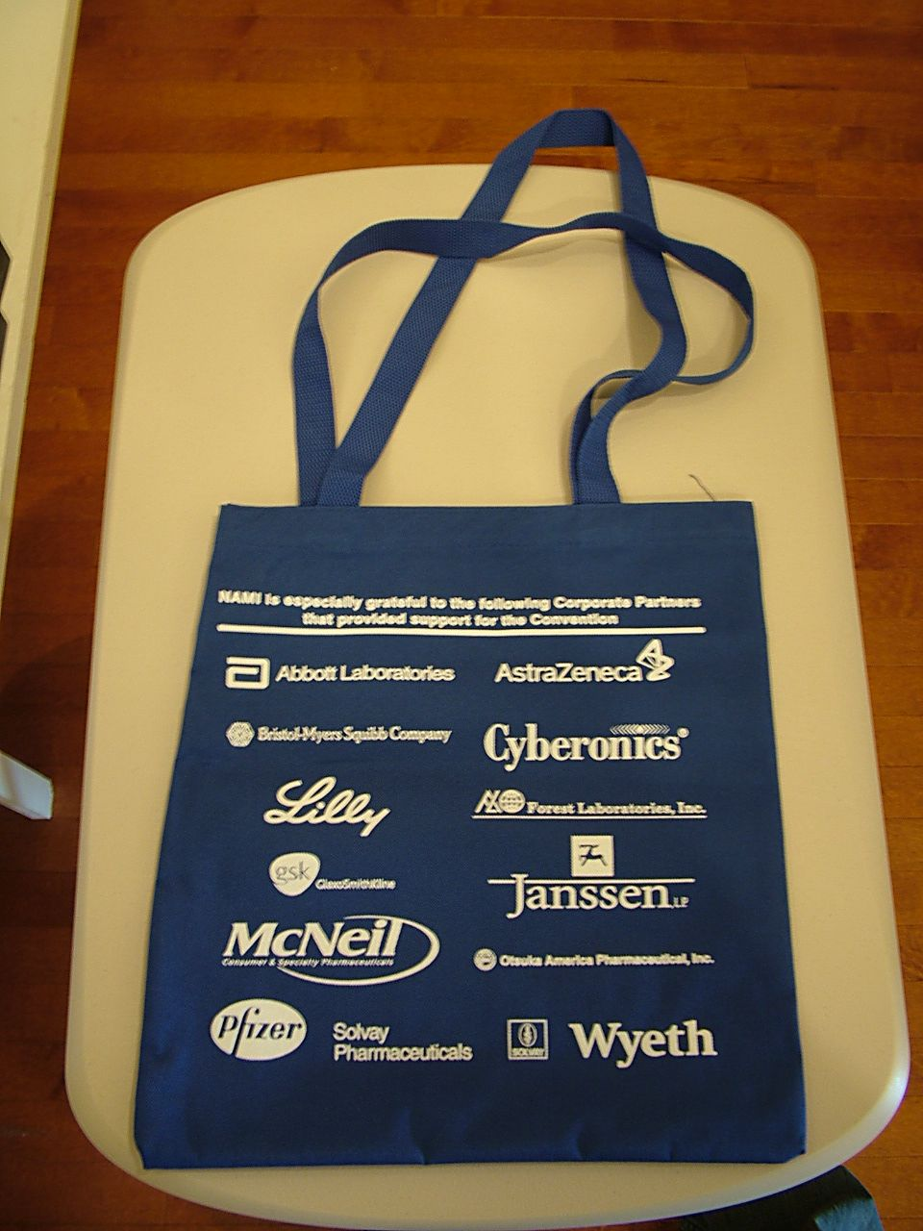

Diagnosis and Treatment based on Social and Political Attitudes and Beliefs
“Intolerance for differences and prejudicial attitudes - All children have likes and dislikes. However, an intense prejudice toward others based on racial, ethnic, religious, language, gender, sexual orientation, ability, and physical appearance — when coupled with other factors — may lead to violent assaults against those who are perceived to be different.” (Early Warning, Timely Response http://www.ed.gov/about/offices/list/osers/osep/gtss.html)
“A…university in St. Paul, Minn., has suspended a student after he raised questions about the campus ban on concealed weapons, and is ordering him to have a mental health evaluation before he can resume his education.” – (http://www.worldnetdaily.com/news/article.asp?ARTICLE_ID=58082)

“Doctors who treat inmates at the California State Prison outside Sacramento concur: They have diagnosed some forms of racist hatred among inmates and administered antipsychotic drugs. ‘We treat racism and homophobia as delusional disorders,’ said Shama Chaiken, who later became a divisional chief psychologist for the California Department of Corrections, at a meeting of the American Psychiatric Association. ‘Treatment with antipsychotics does work to reduce these prejudices.’” (Vedatam, 12/10/05, Washington Post, emphasis added)

“As doctors increasingly weigh the effects of race and culture on mental illness, some are asking whether pathological bias ought to be an official psychiatric diagnosis. Advocates have circulated draft guidelines and have begun to conduct systematic studies. While the proposal is gaining traction, it is still in the early stages of being considered by the professionals who decide on new diagnoses.” (Vedatam, 12/10/05, Washington Post, emphasis added)

Lack of Effectiveness and Harm of Psychiatric Medication
In General
“Little research has been conducted to study the effectiveness of psychosocial interventions in young children, and the long-term risk-benefit ratio of psychosocial and pharmacologic treatments is basically unknown.” (Benedetto Vitiello, chief of child and adolescent psychiatry, NIMH, Pediatrics, 2002)

Antipsychotics
“During longitudinal follow-up, antipsychotic treatment reflected national prescribing practices in 1991 through 2009. Longer follow-up correlated with smaller brain tissue volumes and larger cerebrospinal fluid volumes. Greater intensity of antipsychotic treatment was associated with indicators of generalized and specific brain tissue reduction after controlling for effects of the other 3 predictors. More antipsychotic treatment was associated with smaller gray matter volumes. Progressive decrement in white matter volume was most evident among patients who received more antipsychotic treatment. Illness severity had relatively modest correlations with tissue volume reduction, and alcohol/illicit drug misuse had no significant associations when effects of the other variables were adjusted.” (Ho and Andreasen, Long-term Antipsychotic Treatment and Brain Volumes, Archives of General Psychiatry, VOL 68 (NO. 2), FEB 2011, emphasis added)

“In fact, people with serious mental illness (SMI) are dying 25 years earlier than the general population… Beginning with the introduction of clozapine in 1991, and the subsequent introduction of five newer generation antipsychotics over the next decade or so, antipsychotic prescribing in the US has moved to the use of these second generation antipsychotics. This has occurred despite their significantly greater cost, largely due to a decrease in neurologic side effects and the perception that people using them may experience better outcomes, especially improvement in negative symptoms. However, with time and experience the second generation antipsychotic medications have become more highly associated with weight gain, diabetes, dyslipidemia, insulin resistance and the metabolic syndrome and the superiority of clinical response (except for clozapine) has been questioned. Other psychotropic medications that are associated with weight gain may also be of concern.” (Parks, J. et al, (2006) Morbidity and Mortality in People with Serious Mental Illness, National Association of State Mental Health Program Directors http://www.nasmhpd.org/general_files/publications/med_directors_pubs/Technical%20Report%20on%20Morbidity%20and%20Mortaility%20-%20Final%2011-06.pdf , p. 5-6, emphasis added)

“40% of patients diagnosed with schizophrenia who were NOT on antipsychotic drugs showed periods of recovery and better global functioning compared to only 5% of patients taking antipsychotics (p=.001). ‘These analyses indicated that in addition to the significant differences in global functioning between these groups, 19 of the 23 schizophrenia patients (83%) with uniformly poor outcome at the 15-year follow-ups were on antipsychotic medications.’” (Harriow, et al Do Patients with Schizophrenia Ever Show Periods of Recovery? A 15-Year Multi-Follow-up Study, Schizophrenia Bulletin vol. 31 no. 3 pp. 723-734, 2005. as reported by Sharav, www.ahrp.org, 5/23/07)

Antidepressants
“Results: In adults (aged 19-64 years), antidepressant drug treatment was not significantly associated with suicide attempts (odds ratio [OR], 1.10; 95% confidence interval [CI], 0.86-1.39 [521 cases and 2394 controls]) or suicide deaths (OR, 0.90; 95% CI, 0.52-1.55 [86 cases and 396 controls]). However, in children and adolescents (aged 6-18 years), antidepressant drug treatment was significantly associated with suicide attempts (OR, 1.52; 95% CI, 1.12-2.07 [263 cases and 1241 controls]) and suicide deaths (OR, 15.62; 95% CI, 1.65-infinity [8 cases and 39 controls]).” (Olfson, et al, Antidepressant Drug Therapy and Suicide in Severely Depressed Children and Adults, Arch Gen Psychiatry. 2006; 63:865-872, emphasis added)

“Conclusions: The magnitude of benefit of antidepressant medication compared with placebo increases with severity of depression symptoms and may be minimal or nonexistent, on average, in patients with mild or moderate symptoms. For patients with very severe depression, the benefit of medications over placebo is substantial.” http://jama.amassn.org/cgi/content/abstract/303/1/47

The research had shown that antidepressants help about three quarters of people with depression who take them, a consistent finding that serves as the basis for the oft-repeated mantra "There is no question that the safety and efficacy of antidepressants rest on solid scientific evidence," as psychiatry professor Richard Friedman of Weill Cornell Medical College recently wrote in The New York Times. But ever since a seminal study in 1998, whose findings were reinforced by landmark research in The Journal of the American Medical Association last month, that evidence has come with a big asterisk. Yes, the drugs are effective, in that they lift depression in most patients. But that benefit is hardly more than what patients get when they, unknowingly and as part of a study, take a dummy pill—a placebo. As more and more scientists who study depression and the drugs that treat it are concluding, that suggests that antidepressants are basically expensive Tic Tacs. (Begley, Newsweek, 1/30/10, http://www.newsweek.com/id/232781)

Stimulants
A 2006 Oregon State University review of 2,287 studies involving ADHD drugs found no long-term safety or effectiveness of those drugs in children.



